- Overview sample:
- WHAT

Research question (primary)
What are the minimal, cooperating cellular and molecular events that convert normal thymocyte progenitors into self-renewing leukemia-initiating cells (LICs) in T-ALL — specifically, how do SCL/TAL1 and LMO1 oncogenes, pre-TCR signaling, and activating Notch1 mutations interact mechanistically to initiate and drive clonal T-ALL?

Secondary questions
- At which developmental stage(s) (DN subpopulations / early thymic progenitors) do SCL–LMO1 act to create a cell state permissive for transformation?
- Are activating Notch1 mutations acquired stochastically after oncogenic priming, or selected because they confer a clonal growth/self-renewal advantage in the SCL–LMO1 context?
- Is pre-TCR signaling required for selection/expansion of clones that acquire Notch1 mutations, or can hyperactive Notch1 bypass pre-TCR dependence?

Primary (overarching) hypothesis — testable statement
SCL (TAL1) and LMO1 cooperate to (a) expand primitive thymocyte progenitors and impose a differentiation block, thereby increasing the pool of cells with extended proliferative potential; this altered cellular context, together with pre-TCR signaling, favors the acquisition and clonal fixation of activating Notch1 mutations, producing self-renewing LICs that drive T-ALL.
Null form: SCL–LMO1 expression does not alter progenitor abundance/differentiation in a way that influences the emergence or selection of Notch1 mutant clones; Notch1 mutations arise but do not confer selective clonal dominance in the SCL–LMO1 background.

One-line summary you can present to the committee
SCL and LMO1 cooperate to expand and lock thymocyte progenitors into a proliferative, differentiation-arrested state that, together with pre-TCR signaling, promotes the selection and clonal fixation of activating Notch1 mutations; these combined events produce self-renewing leukemia-initiating cells and represent a minimal, mechanistically defined set of hits sufficient for T-ALL initiation.

- WHY
They arrived at this research question because existing clinical and experimental observations showed the pieces of the disease, but not how those pieces fit together mechanistically. The field knew the players, but not the order of events or how one event enables the next.

Background Knowledge That Motivated the Question
Researchers already knew the following:
Observation (Known) | Gap in Knowledge (Unknown → Motivating question)
SCL/TAL1 and LMO1/2 are overexpressed in ~50–60% of T-ALL. | These oncogenes alone do not cause full leukemia → What do they actually do in early thymocytes?
NOTCH1 activating mutations are found in >50% of T-ALL tumors. | But why and when do these Notch1 mutations appear during transformation?
pre-TCR signaling is a normal checkpoint that expands DN thymocytes and allows developmental progression. | Does this developmental checkpoint become hijacked to aid oncogenic transformation?
T-ALL tumors are clonal (same TCRβ rearrangement + same Notch1 mutations). | Indicates a single initiating cell expands → How does one cell gain self-renewal?
So: The disease seems to require multiple “hits” — but the precise order, dependencies, and interactions were not understood.

Why This Became the Central Research Question
The authors saw a conceptual problem in the field:
We know SCL–LMO1 starts the process but does not complete it.
We know NOTCH1 mutations are frequent, but we don’t know why they are selected.
We know pre-TCR is a developmental checkpoint, but we don’t know whether transformation depends on this checkpoint.
So the critical unknown was:
How do these three events cooperate to turn a normal thymocyte into a leukemia-initiating cell (LIC)?

Therefore, the Research Question Was Formulated:
How do SCL/TAL1 and LMO1 oncogenes, pre-TCR signaling, and activating Notch1 mutations interact mechanistically to initiate and drive clonal T-ALL?
This question directly addresses:
- Mechanistic order (Which event occurs first?)
- Functional cooperation (Which event enables the next one?)
- Cellular consequence (Which thymocyte becomes the LIC?)
- Clonal outcome (Why do tumors have identical Notch1 and TCRβ rearrangements?)

In Simpler Terms
They asked this question because:
- SCL–LMO1 can start abnormal development, but cannot finish the transformation.
- pre-TCR expansion creates “fertile ground” for mutations.
- NOTCH1 activation appears later and gives the cell self-renewal advantage.
They wanted to map the causal sequence:
Initiation → Expansion → Mutation → Leukemic self-renewal → Clonal dominance
This sequencing had never been demonstrated before this study.

- HYPOTHESIS

Specific mechanistic sub-hypotheses (A–D) with predictions and methods
A. SCL+LMO1 → expansion + differentiation arrest of early DN/ETP thymocytes
- Mechanistic claim: Ectopic SCL/LMO1 expression increases proliferation/self-renewal programs and blocks DN→DP progression.
- Predictions: increased frequency/absolute number of Lin⁻ Sca1⁺ c-Kit⁺ (ETP) and DN1–DN3 cells; accumulation of cells with immature markers; altered cell-cycle/proliferation readouts in those populations.
- Key methods that test this: Transgenic mouse crosses + FACS phenotyping (CD44, CD25, CD4/CD8, c-Kit, Sca1; gating for ETPs and DN subsets); quantification and statistical comparison vs controls.
B. SCL+LMO1 create a permissive “pre-leukemic” state that increases the probability of acquiring Notch1 activating mutations
- Mechanistic claim: Expanded progenitor pool with sustained proliferation increases the chance for secondary hits (Notch1) and provides selection pressure for mutations that confer self-renewal.
- Predictions: Notch1 activating mutations will be repeatedly found in tumors arising from SCL–LMO1 mice; time to leukemia correlates with clonal expansion dynamics; sequencing of tumors shows identical Notch1 mutations across tumor cells (clonal fixation).
- Key methods: Notch1 exon sequencing from tumor cDNA (exons 26, 27, 34); timelines/latency analysis (Kaplan–Meier); clonality/Tcrb rearrangement PCR to show single-clone expansion.
C. Activated Notch1 provides a selective advantage in SCL–LMO1 thymocytes and can substitute for pre-TCR signaling
- Mechanistic claim: Notch1 gain-of-function increases self-renewal/proliferation and can both accelerate leukemia onset and, when hyperactive, bypass the requirement for pre-TCR signals.
- Predictions: (1) Introducing a hyperactive Notch1 allele shortens latency and increases penetrance in SCL–LMO1 mice. (2) In genetic backgrounds lacking pre-TCR function (e.g., Rag1⁻/⁻ or Cd3e⁻/⁻), hyperactive Notch1 restores leukemogenesis.
- Key methods: Crosses with Notch1tg mice and pre-TCR-deficient strains; survival curves; transplantation assays to test sufficiency; sequencing/clonality to confirm similar mutation signatures.
D. Tumors arise from clonal expansion of a single LIC that carries both Tcrb rearrangement signature and specific Notch1 mutation
- Mechanistic claim: SCL–LMO1 initiates a pool of predisposed progenitors, but full transformation requires a single cell to acquire cooperating Notch1 mutations and expand clonally into a tumor.
- Predictions: Tumors will show identical Notch1 mutations and identical Tcrb rearrangement patterns across cells (indicative of single-clone origin); transplantation of tumor cells will transfer disease (functional LIC assay).
- Key methods: Tcrb rearrangement PCR (clonality analysis); Notch1 sequencing; transplantation into recipient mice (Rag1⁻/⁻ or Pep3B) to demonstrate leukemia-initiating capacity.

Measurable readouts / how “mechanistic precision” is obtained
- Cellular phenotype: FACS quantification of DN/DP/ETP compartments, proliferation markers, apoptosis.
- Molecular events: Notch1 activating mutations (sequence and domain mapping); qRT-PCR of Notch target genes to show pathway activation; protein localization (Notch1 IF).
- Clonality and timing: Identical Notch1 mutations + Tcrb rearrangement signature across tumor cells; latency analyses to estimate expansion time consistent with single-cell origin.
- Functional sufficiency/necessity: Genetic crosses (add/remove pre-TCR function, hyperactive Notch1), transplantation assays to test LIC function.

- HOW

Research Question
What molecular and cellular events progressively convert normal thymocyte progenitors into leukemic stem cells in SCL–LMO1–driven T-ALL?
Specifically:
- How do SCL + LMO1 affect thymocyte development?
- What is the role of pre-TCR signaling?
- Why are NOTCH1 gain-of-function mutations recurrent in these leukemias?
- When during leukemogenesis does clonal dominance emerge?

Technique-by-Technique Purpose and Contribution
Technique | What it Measures / Detects | Why It Was Done (Specific Purpose) | What It Revealed in This Study (Contribution to Answer)
Transgenic Mouse Models (SCL, LMO1, SCL–LMO1) | In vivo effect of oncogenes on thymocyte development | To see how each oncogene individually or together alters T-cell maturation and proliferation. | SCL + LMO1 together, but not individually, expanded early thymocyte progenitors and blocked later differentiation, creating a “pre-leukemic” pool.
Flow Cytometry (DN1→DN4, DP, SP markers) | Quantifies thymocyte developmental stages | To determine which developmental stage is affected by SCL–LMO1 | Showed accumulation of immature DN progenitors → consistent with differentiation block and expansion of cells receptive to transformation.
Pre-TCR Loss-of-Function / Gain-of-Function Experiments | Tests dependency on pre-TCR signaling | To understand whether pre-TCR is required for progression toward leukemia | Pre-TCR signaling was required to give these progenitors survival/proliferation advantage → essential “second event”.
Notch1 Mutation Sequencing (PCR + Sanger / targeted sequencing) | Detects activating Notch1 mutations | To see when and how Notch1 activation occurs in SCL–LMO1 leukemia | All leukemias developed identical Notch1 gain-of-function mutations → indicates positive clonal selection and that Notch1 activation is a crucial cooperating event.
qRT-PCR for Notch1 Target Genes (Hes1, Deltex, etc.) | Measures transcriptional activation downstream of Notch1 | To confirm whether Notch1 signaling is functionally activated in tumor cells | Demonstrated elevated Notch signaling, confirming Notch1 is not just mutated but actively driving transcriptional programs supporting leukemic growth.
TCRβ (Tcrb) Clonal Rearrangement Analysis | Determines whether tumor cells are clonal or polyclonal | To identify whether leukemia arises from a single transformed progenitor | Found identical Tcrb rearrangements across tumor cells, showing monoclonal expansion from a single leukemia-initiating cell (LIC).
Bone Marrow / Thymocyte Transplantation (Serial Transplantation) | Tests self-renewal and leukemogenic potential of cells | To determine whether transformed cells acquire stem cell–like ability to propagate leukemia | Only cells with SCL + LMO1 + Notch1 activation could self-renew and re-initiate leukemia, defining the leukemia-initiating cell state.
Hyperactive Notch1 Transgene Introduction | Genetic acceleration test | To test whether Notch1 activation is sufficient to drive leukemia faster | Hyperactive Notch1 greatly accelerated leukemia onset and could replace the requirement for pre-TCR, proving Notch1 as a driver, not a passenger.

Conceptual Summary
The data establish a multi-step leukemogenic sequence:
- SCL + LMO1 expand early thymocyte progenitors and block differentiation, creating a pool of susceptible pre-leukemic cells.
- Pre-TCR signaling provides a survival/proliferation advantage, enabling expansion under selective pressure.
- Notch1 gain-of-function mutations appear and become dominant, because they confer strong self-renewal and proliferation advantage.
- Cells with SCL + LMO1 + pre-TCR + Notch1 activation become Leukemia-Initiating Cells (LICs) that drive T-ALL.

- Figures
  - Figure 1
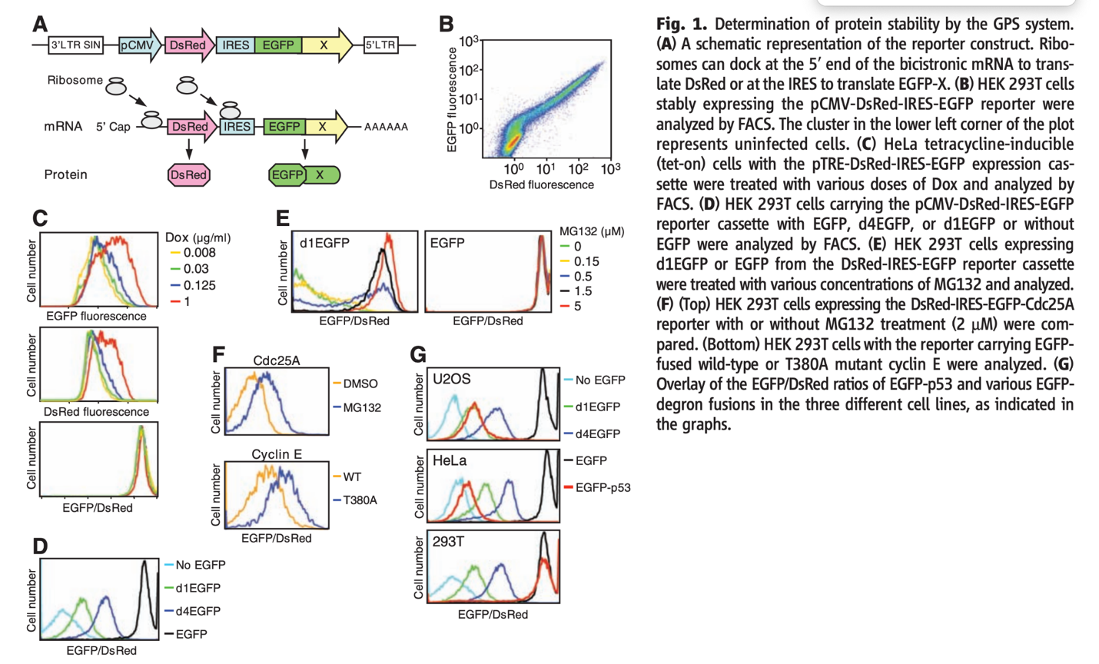

I’ll walk you through how to read each panel, what the axes and coloured lines mean, and the core idea: how the EGFP/DsRed reporter measures protein stability. I’ll keep it practical so you can read the plots yourself.

Big picture (what this reporter measures)
- The construct is bicistronic: DsRed is translated from the 5′ end and EGFP is translated from an IRES downstream, with the protein-of-interest X fused to EGFP (panel A).
- DsRed = internal control (reports how much mRNA/translation the cell made). EGFP = fused to X, so EGFP level depends both on expression and on how stable X is.
- The meaningful quantity is the EGFP/DsRed ratio for each cell. This normalizes away differences in expression and isolates protein stability:
  - High EGFP/DsRed → protein X is stable (less degraded).
  - Low EGFP/DsRed → protein X is unstable (more degraded).

How to read the axes and lines (general rules)
- Histogram plots (most panels):
  - x-axis = fluorescence intensity (usually log scale). When it’s labelled EGFP/DsRed, that axis is the ratio (often plotted on a log scale).
  - y-axis = cell number (counts). The peak(s) show where most cells lie.
  - Each coloured line = the distribution of the cell population under one condition (different Dox doses, drug treatments, constructs, or cell lines).
  - A right shift of the line = higher fluorescence or higher ratio (more EGFP relative to DsRed → more stable). A left shift = lower ratio → less stable / more degradation.
- Scatter plot (panel B): each dot = one cell showing DsRed (x) vs EGFP (y). The cloud shows correlation and spread across single cells.

Panel-by-panel explanation (what each is showing)
A — schematic of reporter.
- Shows how DsRed and EGFP-X are made from the same mRNA. Key point: DsRed controls for expression, EGFP reflects stability of the fused protein X.
B — EGFP vs DsRed scatter (FACS).
- x = DsRed fluorescence; y = EGFP fluorescence.
- Most cells lie on a cloud because higher expression tends to give higher both DsRed and EGFP. What matters is the position relative to the diagonal (ratio) and the spread: broad spread = cell-to-cell variability.
C — dose response to doxycycline (Dox).
- Top: EGFP fluorescence histograms at different Dox doses (colours). Middle: DsRed histograms. Bottom: EGFP/DsRed ratio.
- Observed: both EGFP and DsRed increase with more Dox (right shifts in top two panels), but the EGFP/DsRed ratio stays the same (bottom panel overlapped peaks).
- Interpretation: changing induction strength changes total expression, but relative stability of EGFP-X is unchanged — the ratio normalization worked.
D — control constructs / degron variants.
- Lines: No EGFP (cyan), d1EGFP (green), d4EGFP (blue), EGFP (black). d1/d4 are degron-fused EGFPs (designed to be degraded faster).
- Black (EGFP) is far right (most stable). d1/d4 are left-shifted (lower EGFP/DsRed) showing they are degraded faster. This demonstrates the system can detect differences in stability.
E — MG132 (proteasome inhibitor) dose-response
- Left: d1EGFP EGFP/DsRed histograms at increasing MG132 doses (colours). Right: EGFP (no degron) with MG132.
- For d1EGFP, adding MG132 shifts the distribution right (restores EGFP), meaning the instability was proteasome-dependent.
- For EGFP (stable), MG132 does little — no change because it wasn’t being degraded much.
F — examples with real proteins / mutants
- Top: Cdc25A with DMSO (orange) vs MG132 (blue). MG132 causes a right shift → Cdc25A is degraded by proteasome.
- Bottom: Cyclin E WT (orange) vs mutant T380A (blue). If T380A is shifted right of WT, T380A is more stable than WT (the mutation stabilizes the protein).
- Interpretation rule: when MG132 or a stabilizing mutation shifts the histogram right, that indicates less degradation (higher stability).
G — comparison across cell lines and constructs
- Overlays of EGFP/DsRed for different constructs (No EGFP, d1EGFP, d4EGFP, EGFP-p53, EGFP) in U2OS / HeLa / 293T.
- You can see how the same fusion behaves differently in different cell types (some cell lines may have more active degradation machinery or different E3 ligases).

What a single experimenter should look for (practical readout)
- Compare medians (or geometric means) of EGFP/DsRed between constructs or treatments. That single number quantifies stability.
  - e.g. fold-change = median(EGFP/DsRed with MG132) / median(EGFP/DsRed vehicle).
- Look at histogram shifts: single narrow peak shifting right = uniform stabilization; broadening or bimodality suggests subpopulations.
- Test proteasome dependence: if MG132 shifts ratio right, degradation is proteasome-mediated.
- Use controls: Bare EGFP (stable) and known degron constructs (d1/d4) validate assay sensitivity.
- Check expression (DsRed) to ensure changes are not due to transcription/translation changes — that’s why ratio normalization is essential.

Quick decision/interpretation cheatsheet
- EGFP/DsRed right shift → more stable (less degraded).
- EGFP/DsRed left shift → less stable (more degraded).
- MG132 increases EGFP/DsRed → proteasome-dependent degradation.
- Mutation that causes right shift → mutation stabilizes protein.
- Different cell lines: same construct can behave differently (different degradation machinery).

  - Figure 2

